**Assignment 10**

**Create appropriate indexes to solve following problems.**

**Note : use “sales” database to solve below queries.**

1. Create an index that will enable a user to pull orders for ‘1990-10-03’ out of the Orders table quickly.

Before indexing- **explain format = json select * from orders where odate='1990-10-03';**

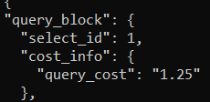

For indexing-**create index idx_order_odate on orders(odate);**

After indexing- **explain format = json select * from orders where odate='1990-10-03';**

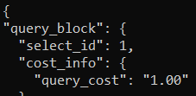

1. If the Orders table has already been created, how can you force the onum field to be unique (assume all current values are unique)?

**create unique index idx_order_onum on orders(onum);**

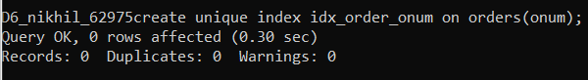

**insert into orders(onum) values(3005);**



1. Create an index that would permit salesperson to retrieve his orders.

**create index idx_order_snum on orders(snum);**

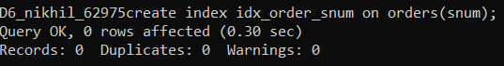

1. Let us assume that each salesperson is to have only one customer of a given rating, and that this is currently the case. Create an index that enforces it.

**create unique index idx_customer_rating on customers(cnum,rating);**



1. Create an index to speed up searching order on a given date by given customer

**create index idx_order_cnum_date on orders(cnum,odate);**

